Design Principles - Scalability & Performance Awareness
# Source: AI Source: Provided by: [Data Path: Persons Table -> ID Column: 1, Name_En Column: Motasem Essam] -> From: [ChatGPT] on [1/23/2026]
Scalability & Performance Awareness is the principle of designing software systems to handle growth in users, data, and load efficiently, while maintaining acceptable performance.
👉 Think of it like building roads wide enough for future traffic instead of just the cars you have today.

🔑 Key Points
# Source: AI Source: Provided by: [Data Path: Persons Table -> ID Column: 1, Name_En Column: Motasem Essam] -> From: [ChatGPT] on [1/23/2026]
- Scalability: Ability to grow without breaking the system
  - Horizontal scaling: Add more servers or instances
  - Vertical scaling: Increase resources (CPU, RAM) on existing servers
- Performance awareness: Write efficient code and optimize resource usage
- Anticipate bottlenecks early in design
- Consider caching, asynchronous processing, and load balancing

❌ Bad Example
# Source: AI Source: Provided by: [Data Path: Persons Table -> ID Column: 1, Name_En Column: Motasem Essam] -> From: [ChatGPT] on [1/23/2026]
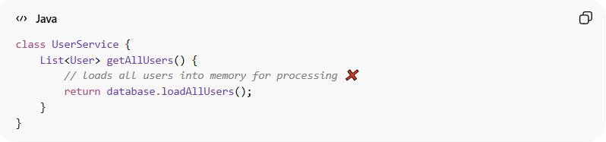
class UserService {
List<User> getAllUsers() {
// loads all users into memory for processing ❌
return database.loadAllUsers();
}
}
Problems:
- Loads everything into memory → poor performance with large data
- Not designed to scale with thousands or millions of users
- No caching, batching, or pagination

✅ Good Example
# Source: AI Source: Provided by: [Data Path: Persons Table -> ID Column: 1, Name_En Column: Motasem Essam] -> From: [ChatGPT] on [1/23/2026]
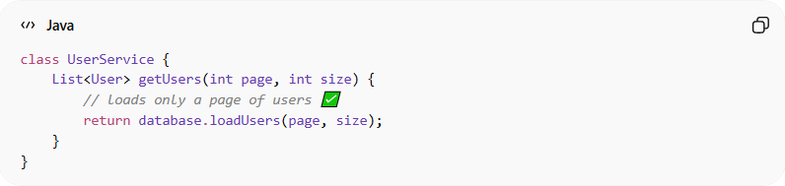
class UserService {
List<User> getUsers(int page, int size) {
// loads only a page of users ✅
return database.loadUsers(page, size);
}
}
Benefits:
- Handles large datasets efficiently
- Supports future growth
- Reduces resource consumption
- Improves user experience and system reliability

⚡ When to Apply
# Source: AI Source: Provided by: [Data Path: Persons Table -> ID Column: 1, Name_En Column: Motasem Essam] -> From: [ChatGPT] on [1/23/2026]
- Always for web applications, microservices, and enterprise systems
- Consider expected load, growth, and peak usage
- Combine with modularity, loose coupling, and high cohesion for optimal performance

